

School of Computer Science Engineering and Information Systems

Fall Semester 2026-2027

Department of Software and Systems Engineering

SWE3004 - Software Design and Development Project

Date: 07.10.2026

Agriculture Farm Digital Twin for Scenario Analysis
22MIS0576 – N.Sakthivel

Under the Guidance of
Dr. Priya V

SCORE

Guide Signature with date

Internal Examiner -1 Internal Examiner-2
Signature Signature
ABSTRACT:

Agriculture is affected by changing weather conditions, soil properties, crop performance, and market price variations, making farm-level decision-making difficult for small and marginal farmers. This project, Agriculture Farm Digital Twin for Scenario Analysis, develops a software-based digital representation of a farm using publicly available agricultural and environmental data without requiring physical IoT sensors. The system integrates historical weather, soil properties, crop yield, market prices, and vegetation index information for the Ariyalur region. A Random Forest model is used for crop yield prediction after comparing different machine learning models, while conformal prediction provides an uncertainty range for the predicted yield. The system also provides what-if scenario analysis by allowing changes in rainfall and temperature and evaluates their effects on yield, production, revenue, input cost, and net profit. SHAP is used to explain the important factors influencing yield predictions. Historical AGMARKNET data is used for market price projection, and a RAG-based chatbot provides agricultural recommendations using farm information and TNAU-based knowledge. The system is implemented using Flask, React, and PostgreSQL/PostGIS with SQLite fallback. The proposed system provides an affordable software-based decision-support platform for analysing farm conditions and comparing different agricultural scenarios.

Keywords:
Agriculture, Digital Twin, Digital Shadow, Crop Yield Prediction, Random Forest, Conformal Prediction, Scenario Analysis, SHAP, Market Price Forecasting, RAG, Agricultural Decision Support.

1. INTRODUCTION
Agriculture is an important part of the livelihood of many farmers, but crop production is affected by weather conditions, soil properties, crop performance, and market price changes. Small and marginal farmers may find it difficult to analyse these factors together and make suitable decisions about crop planning, irrigation, and selling time. A Digital Twin provides a digital representation of a physical system that can be used for prediction and analysis. In agriculture, such a system can help analyse farm conditions and support better decision-making. However, many existing agricultural systems depend on sensors and IoT devices, which can increase the cost and complexity of deployment. This project develops a software-based Agriculture Farm Digital Twin for Scenario Analysis using publicly available weather, soil, historical yield, market price, and vegetation index data. The system provides yield prediction, uncertainty estimation, what-if scenario analysis, economic evaluation, explainability, and agricultural recommendations through a web-based dashboard. The implementation focuses on the Ariyalur region and provides a low-cost approach for analysing different agricultural conditions without requiring physical IoT sensors.

2. PROBLEM STATEMENT
Small and marginal farmers face difficulties in making effective decisions about crop planning, irrigation, and selling because agricultural production is influenced by changing weather conditions, soil properties, crop yield, and market prices. Existing data-driven agricultural systems often depend on costly sensors and IoT devices for continuous field monitoring, making them difficult to access and deploy for small-scale farming. There is a need for an affordable software-based system that can combine agricultural and environmental data, predict crop yield, analyse different weather conditions, estimate economic outcomes, and provide understandable recommendations without requiring physical sensors.

3. OBJECTIVES
- To develop a software-based Agriculture Farm Digital Twin using publicly available agricultural and environmental data.
- To integrate weather, soil, historical crop yield, market price, and vegetation index information for farm representation.
- To develop a machine learning model for crop yield prediction.
- To provide an uncertainty range for the predicted yield using conformal prediction.
- To develop what-if scenario simulation for analysing changes in rainfall and temperature.
- To estimate production, revenue, input cost, and net profit under different scenarios.
- To use SHAP to explain the important factors influencing yield prediction.
- To provide market price projections using historical AGMARKNET data.
- To provide agricultural recommendations through a RAG-based chatbot using farm information and TNAU-based knowledge.
- To provide these functions through a web-based dashboard for agricultural decision support.

4. SCOPE OF THE PROJECT
The project focuses on developing a software-based digital representation of a farm for agricultural decision support. The implementation focuses on the Ariyalur region and uses publicly available weather, soil, historical crop yield, market price, and vegetation index data. The system covers crop yield prediction, uncertainty estimation, market price projection, what-if scenario analysis, economic evaluation, SHAP-based explainability, and agricultural recommendations through a web dashboard. The system is designed to work without physical IoT sensors. The current implementation is limited to the available historical dataset and selected crops and does not include physical sensor deployment, automated farm machinery, real-time field actuation, or financial transactions.

5.LITERATURE SURVEY: (minimum 15 papers)

S.No | Title & Citation | Merits | Demerits
1 | Haji Seyed Asadollah, S. B., Jodar-Abellan, A., & Pardo, M. Á. (2024). Optimizing machine learning for agricultural productivity: A novel approach with RScv and remote sensing data over Europe. Agricultural Systems, 218, 103955. | Uses a new tuning method (RScv) to make ML models like AdaBoost and Random Forest predict crop yield better. Tested on four crops across 20 European countries over 20 years, with accuracy around 0.90 for the best model. Also checks how confident the model is in its predictions. | Only focuses on predicting yield, not building a full farm-level twin. Doesn't include farmer decisions, market prices, or management data. Authors themselves say more variables and wider testing are needed.
2 | Kamangir, H., Sams, B. S., Dokoozlian, N., Sanchez, L., & Earles, J. M. (2024). Large-scale spatio-temporal yield estimation via deep learning using satellite and management data fusion in vineyards. Computers and Electronics in Agriculture, 216, 108439. | Combines satellite images with farm management details (like row spacing) to predict grape yield early in the season. Tested on almost 5 million grapevines over 4 years, giving solid accuracy (R² = 0.76). | Built only for vineyards, so it won't directly work for other crops like rice or cotton. Needs detailed management data that small farmers may not have. Only predicts yield, doesn't simulate different farming choices.
3 | Mitsanis, C., Hurst, W., & Tekinerdogan, B. (2024). A 3D functional plant modelling framework for agricultural digital twins. Computers and Electronics in Agriculture, 218, 108733. | Proposes a way to add realistic 3D plant models into digital twins, so the twin can simulate things like plant growth, disease spread, and pruning. | Mostly a theoretical framework, not a working farmer-facing system. Building 3D plant models needs heavy computing power. Doesn't cover market prices or decision support for farmers.
4 | Cohen, Y., Malka, A., Goldwasser, Y., Scudiero, E., Goldshtein, E., Keisar, O., Lidor, G., & Ravid, G. (2025). Leveraging satellite imagery and yield records to assess in-season maize field functionality with machine learning classification. Computers and Electronics in Agriculture, 238, 110809. | Uses satellite images and past yield data to check how well a maize field is performing during the season, not just at harvest. Combining different types of features improved accuracy noticeably. Even built a web-based tool for this. | Only works for maize fields and needs historical yield records, which not every farmer has. It classifies field performance, but doesn't predict final yield or simulate future decisions.
5 | Onoufriou, G., Hanheide, M., & Leontidis, G. (2023). Premonition Net, a multi-timeline transformer network architecture towards strawberry tabletop yield forecasting. Computers and Electronics in Agriculture, 208, 107784. | Uses a transformer model that looks at past, present, and expected future data together to predict strawberry yield 3 weeks ahead, with good accuracy. Useful for planning labor and sales in advance. | Built only for strawberries grown on tabletops, needing very specific and detailed data. The authors themselves say getting enough good data is still a big problem. Not a general farm decision-support tool.
6 | Cesco, S., Sambo, P., Borin, M., Basso, B., Orzes, G., & Mazzetto, F. (2023). Smart agriculture and digital twins: Applications and challenges in a vision of sustainability. European Journal of Agronomy, 146, 126809. | Suggests designing farm systems around what decisions farmers actually need to make, not just collecting data for its own sake. Shows this idea with a real example on nitrogen fertilizer use. Talks about the special challenges small farms face. | Mainly a concept paper and case study, not a full working software system. Talks about many technologies that can be costly to set up. Doesn't give a ready-to-use forecasting or simulation tool.
7 | Paudel, D., de Wit, A., Boogaard, H., Marcos, D., Osinga, S., & Athanasiadis, I. N. (2023). Interpretability of deep learning models for crop yield forecasting. Computers and Electronics in Agriculture, 206, 107663. | Shows that deep learning models like LSTM can be made understandable by checking which features influence the prediction, and gets experts to verify if this matches real farming knowledge. Proves that accuracy and explainability can go together. | The explanations are added after the model makes its prediction, so they don't always capture how features interact with each other. Needs a lot of training data. The explanation method itself is only an approximation.
8 | Leukel, J., Zimpel, T., & Stumpe, C. (2023). Machine learning technology for early prediction of grain yield at the field scale: A systematic review. Computers and Electronics in Agriculture, 207, 107721. | Reviews 46 different studies on early yield prediction, showing what data and methods are commonly used, and how far in advance predictions can be made. Useful as a broad reference. | The studies reviewed are very different from each other in datasets and methods, making it hard to directly compare. Many studies didn't properly report their data sizes or use good feature selection.
9 | Tripathi, A., Kaushal, I., Revolti, A., Benedetti, L., & Dallasega, P. (2025). Digital twin driven quality control in smart mobile factories: A framework in precast manufacturing. Procedia CIRP, 134, 801–806. | Shows how a digital twin can combine sensor data and manual inspection data to catch quality problems early and create feedback loops for better decisions — an idea borrowed here from outside agriculture. | Built for precast concrete manufacturing, not farming. Relies heavily on sensors and industrial-scale computing, which wouldn't directly work for smallholder farms without major changes.
10 | Purcell, W., & Neubauer, T. (2023). Digital twins in agriculture: A state-of-the-art review. Smart Agricultural Technology, 3, 100094. | Reviews existing agricultural digital twins and clearly separates the levels of "twin-ness" — Digital Model, Digital Shadow, and full Digital Twin — helping define what a system should be called. Points out that true digital twins need two-way, real-time data flow. | It's a review paper, not a working system. It notes that most existing digital twins are still just pilot projects, mostly in greenhouses or aquaponics, and that "what-if" simulation is still rare in practice.
11 | Singh, N., Wang'ombe, J., Okanga, N., Zelenska, T., Repishti, J., G K, J., Mishra, S., Manokaran, R., Singh, V., Rafiq, M. I., Gandhi, R., & Nambi, A. (2024). Farmer.Chat: Scaling AI-powered agricultural services for smallholder farmers. arXiv preprint, arXiv:2409.08916. | A generative AI chatbot deployed in 4 countries, used by over 15,000 farmers, answering more than 300,000 questions. Supports multiple languages and even images/audio, which helps low-literacy farmers. Uses RAG so answers are grounded in real agricultural documents. | Depends on having a large, well-curated knowledge base to stay accurate — hard to maintain and localize everywhere. The paper notes concerns about bias, data privacy, and farmers becoming too dependent on the tool. It's a general advisory chatbot, not linked to a farm-specific forecasting/simulation model.
12 | Manogna, R. L., Dharmaji, V., & Sarang, S. (2025). Enhancing agricultural commodity price forecasting with deep learning. Scientific Reports, 15(1), 20903. | Compares many models (LSTM, GRU, ARIMA, etc.) to forecast prices of 23 different crops using 14 years of Indian market data. Shows LSTM and GRU clearly beat older statistical methods, which is useful for farmers deciding when/what to sell. | Focuses only on price forecasting, with no link to weather, soil, or yield data. Doesn't help farmers decide what to plant — only what prices might look like. Suggests future work should combine price data with other factors like weather.
13 | Petropoulos, T., Benos, L., Berruto, R., Miserendino, G., Marinoudi, V., Busato, P., Zisis, C., & Bochtis, D. (2025). Interpretable machine learning for legume yield prediction using satellite remote sensing data. Applied Sciences, 15(13), 7074. | Combines satellite images with SHAP explainability to predict lupin (a legume) yield and clearly show which factors drove each prediction — directly relevant to building trustworthy, explainable advisory tools. | Focused on one under-studied crop (lupin) in one region of Italy, so results may not transfer elsewhere. Doesn't include a scenario simulation or advisory chatbot layer — stops at prediction and explanation.
14 | Jácome Galarza, L., Realpe, M., Viñán-Ludeña, M. S., Calderón, M. F., & Jaramillo, S. (2025). AgriTransformer: A transformer-based model with attention mechanisms for enhanced multimodal crop yield prediction. Electronics, 14(12), 2466. | Uses a transformer model with attention to combine multiple types of data (like satellite and weather) for more accurate yield prediction — directly relevant to the LSTM/transformer approach planned for this project. | Focused purely on prediction accuracy, without any decision-support, scenario simulation, or farmer-facing explanation layer. Multimodal transformer models can be computationally heavy to deploy at low cost.
15 | Lal, B., Shukla, A., Agrawal, A. K., Ramasamy, R. K., & Dubey, P. (2026). Attention-based transformer framework with predictive uncertainty quantification for multi-crop yield forecasting. Computation, 14(4), 93. | Directly relevant to this project's "calibrated confidence" goal — combines a transformer model with three different ways (Monte Carlo Dropout, Quantile Regression, Bayesian Attention) of estimating how confident the model is, not just a single yield number. | Tested only on coarse tabular climate/soil data, not high-resolution satellite imagery. The authors note it's an integration of existing uncertainty techniques rather than a completely new method. Still just a forecasting model, with no scenario simulation or advisory layer.

5.1 FINDINGS IN LITERATURE SURVEY:
- Most existing studies mainly focus on crop yield prediction.
- Many systems do not provide complete decision support for farmers.
- Several agricultural Digital Twin systems depend on IoT sensors, which can be costly for small and marginal farmers.
- Prediction confidence and explainability are not commonly provided together.
- Yield prediction and market price prediction are usually handled separately.
- Most systems do not provide what-if scenario analysis for:
  - Low rainfall
  - High temperature
  - Market price changes
- There is a research gap in combining Digital Twin, ML prediction, confidence, explainability, scenario testing, and market information in one system.
- A sensor-free system with farm-specific recommendations can help address this gap.

6.DESIGN & METHEDOLOGY
The proposed Agriculture Farm Digital Twin for Scenario Analysis is designed as a software-based decision-support system for analysing farm conditions and possible future scenarios. The system uses publicly available agricultural and environmental data instead of physical IoT sensors. The overall design combines data processing, digital farm representation, machine learning, uncertainty estimation, scenario simulation, economic analysis, explainability, and agricultural advisory.
6.1 Data Collection
The system collects data required for farm analysis from public sources. The main data used are weather, soil, historical crop yield, market price, and vegetation index data. Weather information includes rainfall, temperature, ET0, and wind speed. Soil information is obtained from SoilGrids, historical yield data is used for model training, and AGMARKNET data is used for market price analysis.
6.2 Data Preprocessing
The collected datasets are cleaned and prepared before analysis. Missing values are handled, data formats are standardised, and relevant agricultural features are selected. Weather, price, crop, and yield information are combined to create the dataset used for prediction.
6.3 Digital Farm Representation
The processed information is used to create a digital representation of the selected farm. The digital representation contains farm location, crop information, soil properties, weather conditions, vegetation index, historical yield, and market information. PostgreSQL/PostGIS is used as the main database, with SQLite available as a fallback.
6.4 Crop Yield Prediction
Different machine learning approaches are compared for crop yield prediction. The implemented system evaluates Random Forest, Gradient Boosting, and a deep-learning benchmark. Random Forest is selected as the final model because it performs better on the available small tabular dataset.
The Random Forest model uses agricultural and environmental features to predict crop yield in tonnes per hectare.
6.5 Uncertainty Estimation
Instead of providing only a single yield value, the system uses conformal prediction to provide an uncertainty range. Out-of-fold residuals are used to calculate the prediction margin. The implementation targets a 90% prediction interval.
6.6 Market Price Projection
Historical AGMARKNET market prices are processed and aggregated to generate future price projections. The price forecast provides an estimated price range that can be used along with predicted crop yield for economic analysis.
6.7 What-If Scenario Simulation
The system provides a scenario engine for analysing changes in environmental conditions. Users can modify rainfall and temperature values and observe their possible effect on crop yield.
The system includes predefined scenarios such as drought, supplemental micro-irrigation, delayed sowing, and crop switching. It also supports custom scenarios through user-controlled rainfall and temperature inputs.
6.8 Economic Evaluation
The scenario results are converted into economic values. The system calculates production, revenue, input cost, and net profit.
Production = Predicted Yield × Farm Area
Gross Revenue = Production × Market Price
Net Profit = Gross Revenue − Input Cost
This allows different scenarios to be compared based on both agricultural and economic outcomes.
6.9 SHAP-Based Explainability
SHAP is used to explain the Random Forest prediction. The system identifies the features that have the largest contribution to the predicted yield. These explanations help the user understand the factors influencing the prediction instead of receiving only a prediction value.
6.10 RAG-Based Agricultural Advisory
The agricultural chatbot uses the digital farm context, prediction results, SHAP information, and TNAU-based agricultural knowledge to provide recommendations. The retrieved context is used to make the recommendations more relevant to the selected farm and scenario.
6.11 Web Application Design
The complete system is implemented as a web application. The React frontend provides the user interface, while the Flask backend provides REST APIs for the different modules. The database stores farm and agricultural information.

7. METHODOLOGY
- Data Collection: Collect weather, soil, satellite/vegetation, historical crop yield, and market price data from public sources.
- Data Preprocessing: Clean the collected data, handle missing values, remove inconsistencies, and prepare the data for analysis.
- Digital Farm Representation: Create a software-based digital representation of the farm using location, soil, weather, crop, yield, and market information.
- Yield Prediction: Use machine learning models to predict crop yield based on the available farm and environmental data.
- Uncertainty Estimation: Apply conformal prediction to provide an uncertainty range along with the predicted yield.
- Market Price Projection: Use historical AGMARKNET market data to estimate future crop prices.
- Scenario Simulation: Allow users to change conditions such as rainfall and temperature and analyse their effect on crop yield.
- Economic Analysis: Calculate production, revenue, input cost, and net profit for different scenarios.
- Explainability: Use SHAP to identify and explain the important factors affecting the yield prediction.
- Agricultural Advisory: Use a RAG-based chatbot with farm information and TNAU-based agricultural knowledge to provide recommendations.
- Web Application: Integrate all the modules into a React dashboard connected to the Flask backend and database.

8. SOFTWARE REQUIREMENTS:
Functional Requirements
- User Authentication: Provide user registration, login, logout, and role-based access for farmers and cooperative administrators.
- Farm Profile Management: Allow users to create and manage farm profiles using farm name, location, area, crop, and soil information.
- Agricultural Data Integration: Collect and use weather, soil, historical crop yield, market price, and vegetation index data from public sources such as Open-Meteo, SoilGrids, APY, and AGMARKNET.
- Digital Farm Representation: Create a software-based Digital Shadow of the farm by combining location, weather, soil, satellite/vegetation information, yield history, and market information.
- Yield Prediction: Predict crop yield in tonnes per hectare using machine learning models, with Random Forest selected based on model comparison.
- Uncertainty Estimation: Provide a conformal prediction interval along with the predicted yield to show the possible range of the prediction.
- Market Price Projection: Analyse historical AGMARKNET mandi prices and provide future price projections with confidence bands and selling recommendations.
- What-If Scenario Simulation: Allow users to change rainfall and temperature conditions and analyse their effect on crop yield and farm outcomes.
- Economic Analysis: Calculate production, gross revenue, input cost, net profit, and profit changes for different scenarios.
- Explainability: Use SHAP to identify the important factors influencing the crop yield prediction and present them in an understandable form.
- Agricultural Chatbot: Provide a RAG-based chatbot using farm information, model results, SHAP explanations, and TNAU agricultural knowledge for farm-related recommendations.
- Dashboard: Provide a React-based web dashboard to display the digital farm, weather, soil, yield forecast, price forecast, scenario results, economic analysis, explanations, and chatbot.
- Cooperative View: Provide a cooperative-level view for multi-farm aggregation, total production, and regional value/risk information.
Non-Functional Requirements
- Performance: The system should provide API responses, predictions, scenario simulations, and dashboard results within a reasonable response time.
- Reliability: The system should handle missing data and unavailable external data sources using available fallback data where implemented.
- Prediction Reliability: Yield predictions should include uncertainty information instead of displaying only a single predicted value.
- Security: Protect user authentication information and restrict system functions based on the assigned user role.
- Usability: Provide a simple and interactive dashboard with charts, scenario controls, explanations, and farmer-friendly recommendations.
- Maintainability: Keep the system modular by separating data services, ML models, scenario engine, SHAP explainability, RAG chatbot, Flask APIs, and React frontend.
- Scalability: The architecture should allow additional farms, crops, and regional data to be added without changing the complete system design.
- Cost Efficiency: Use publicly available agricultural and environmental datasets and a software-based approach without requiring physical IoT sensors.
- Fallback Support: Support SQLite fallback when PostgreSQL/PostGIS is unavailable, while PostgreSQL/PostGIS is used as the main spatial database.

[9.] SYSTEM ARCHITECTURE:

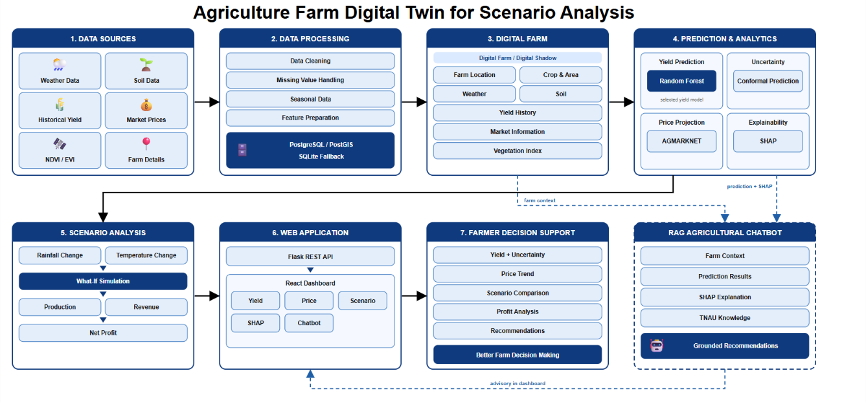

Fig. 9.1 System Architecture
10. UML DIAGRAMS:
Use Case Diagram:
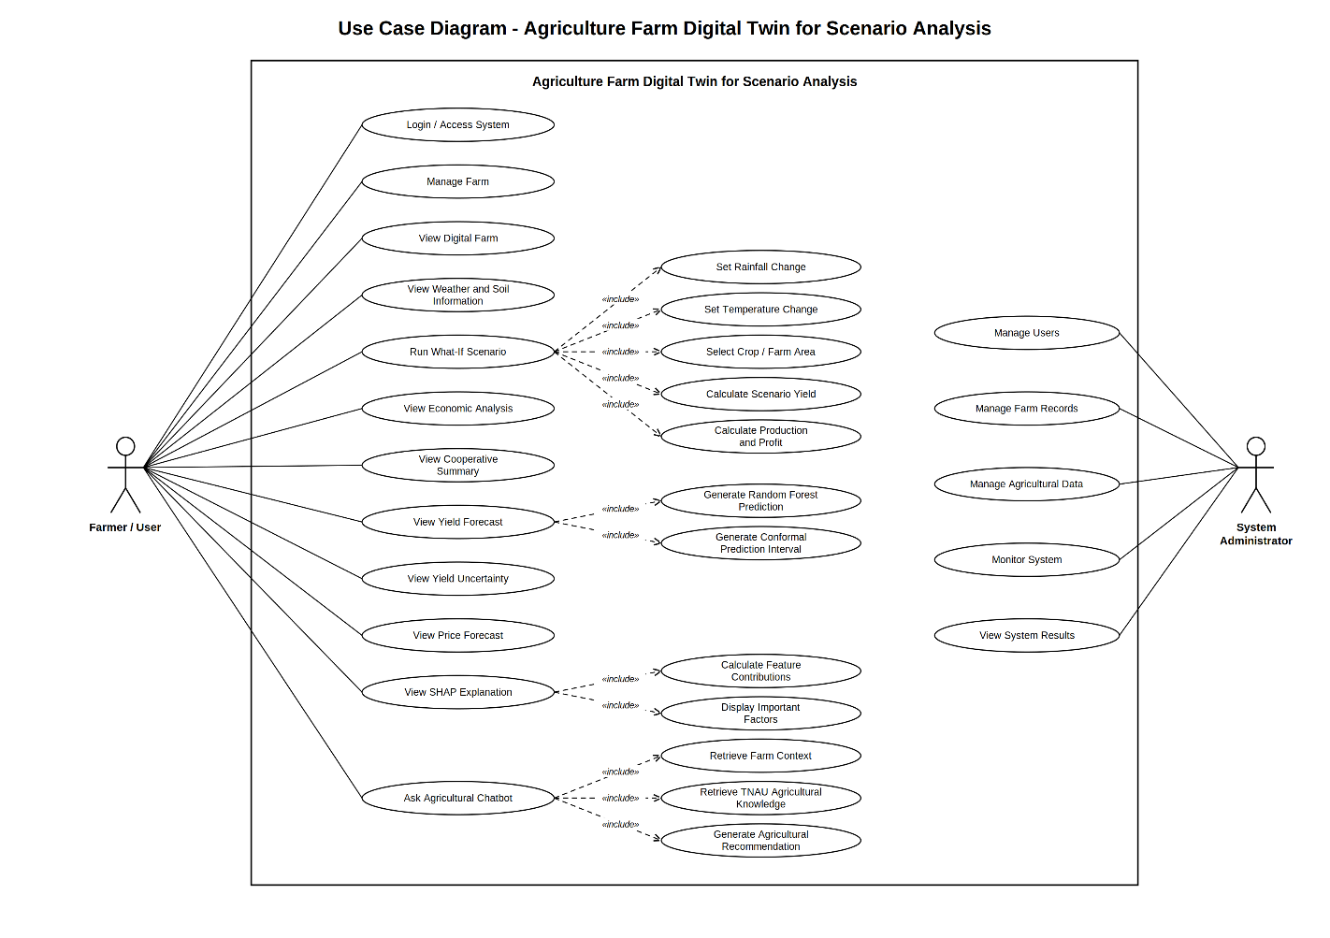
Class Diagram:
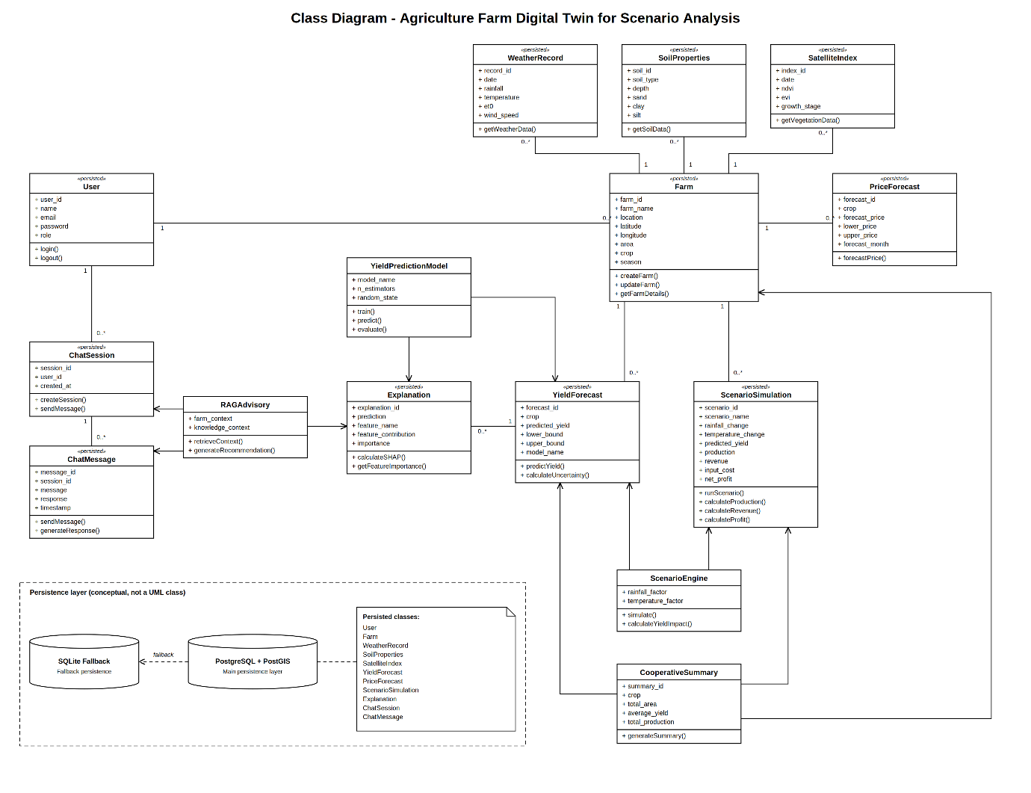11. IMPLEMENTATION
The proposed Agriculture Farm Digital Twin for Scenario Analysis is implemented as a web-based software system. The implementation consists of a Flask backend, React frontend, database layer, machine learning modules, scenario simulation, explainability, economic analysis, and RAG-based agricultural advisory.
11.1 Backend Implementation
The backend is developed using Flask and provides REST APIs for the major system functions. The backend handles farm information, digital farm data, yield forecasting, price forecasting, scenario simulation, SHAP explanations, chatbot services, and cooperative summaries.
11.2 Database Implementation
The system uses PostgreSQL with PostGIS for storing farm and agricultural information. SQLite is provided as a fallback for local execution. The database contains information related to users, farms, weather records, soil properties, satellite indices, forecasts, scenarios, explanations, and chat sessions.
11.3 Yield Prediction Implementation
The yield prediction module compares different machine learning approaches and selects Random Forest as the final model. The model uses weather, price, crop, year, and other prepared features to predict crop yield in tonnes per hectare.
The implemented Random Forest uses 100 trees and random_state=42. Model performance is evaluated using MAE, MAPE, and R².
11.4 Uncertainty Implementation
Conformal prediction is implemented using out-of-fold residuals to provide an uncertainty range around the predicted yield. The system targets a 90% prediction interval.
11.5 Price Forecasting Implementation
The price forecasting module uses historical AGMARKNET market price data. The data is aggregated and used to generate future price projections and price ranges for economic analysis.
11.6 Scenario Simulation Implementation
The scenario module allows users to modify rainfall and temperature conditions. The system applies the implemented scenario calculations and predicts the resulting yield and economic outcome.
The system supports predefined scenarios such as drought, supplemental irrigation, delayed sowing, and crop switching. A custom scenario option also allows users to enter their own rainfall and temperature changes.
11.7 Economic Analysis Implementation
The system calculates production, revenue, input cost, and net profit for each scenario.
Production = Predicted Yield × Farm Area
Gross Revenue = Production × Market Price
Net Profit = Gross Revenue − Input Cost
This allows users to compare scenarios based on economic outcome.
11.8 SHAP Implementation
SHAP is implemented using the tree-based model to explain the contribution of different features to the yield prediction. Both feature importance and individual prediction explanations are provided.
11.9 RAG Chatbot Implementation
The RAG-based chatbot uses the digital farm context, prediction results, SHAP information, and TNAU-based agricultural knowledge to generate relevant agricultural recommendations.
11.10 Frontend Implementation
The frontend is developed using React with Vite. The dashboard provides separate interfaces for:
- Farm Dashboard
- Yield Forecast
- Price Forecast
- What-If Scenario
- Economic Analysis
- SHAP Explainability
- Agricultural Chatbot
- Farm Management
- Cooperative View
The implemented workflow and modules are documented in the current project implementation.

11.1. PROJECT PLAN
The development of the Agriculture Farm Digital Twin for Scenario Analysis was organized into structured phases covering requirement analysis, agricultural data collection, data preprocessing, digital farm representation, machine learning model development, uncertainty estimation, market price analysis, scenario simulation, explainability, agricultural advisory, web application development, testing, and final integration. The phased approach helped in developing the system module by module and integrating the different components into a single software-based decision-support platform without requiring physical IoT sensors.
Phase 1 – Requirement Analysis
This phase focused on identifying the major problems faced by small and marginal farmers in crop planning and decision-making. The functional requirements were defined for farm profile management, agricultural data integration, crop yield prediction, market price projection, what-if scenario analysis, economic evaluation, SHAP-based explainability, agricultural chatbot support, and dashboard visualization. The system was designed as a software-based solution without physical IoT sensors.
Phase 2 – System Design and Architecture
During this phase, the overall architecture of the system was designed as a modular full-stack application. The architecture consists of a Flask REST API backend, React/Vite frontend, PostgreSQL/PostGIS database with SQLite fallback, machine learning models, scenario engine, SHAP explainability module, and RAG-based agricultural advisory module. The database structure was also designed to store users, farms, weather, soil, satellite indices, forecasts, scenarios, explanations, and chatbot information.
Phase 3 – Public Agricultural Data Collection
This phase involved collecting the datasets required for developing the digital farm representation and prediction models. Weather information was obtained from Open-Meteo and historical weather sources, soil information from ISRIC SoilGrids, historical crop yield from the APY government database, and market prices from AGMARKNET. Vegetation information was represented using calibrated NDVI/EVI phenological data.
Phase 4 – Data Preprocessing and Training Dataset Creation
The collected data was cleaned and prepared for model development. Historical weather and market data were organized according to agricultural seasons, and the required features were generated. Missing market price values were handled using crop-specific mean values. Weather, price, and yield information were then combined to create the 36-record Ariyalur training dataset used for machine learning.
Phase 5 – Digital Farm / Digital Shadow Development
In this phase, the collected information was combined to create the software-based digital representation of the farm. The digital shadow contains farm location, area, crop information, weather conditions, soil properties, vegetation information, historical yield, and market information. PostgreSQL/PostGIS was used for spatial storage with SQLite available as a fallback.
Phase 6 – Machine Learning Model Development
The crop yield prediction module was developed using different machine learning approaches. Random Forest, Gradient Boosting, and a PyTorch MLP/LSTM benchmark were evaluated using the same historical dataset. Leave-One-Out Cross-Validation was used for model evaluation. Random Forest was selected as the production model because it achieved the lowest reported MAE of approximately 0.963 t/ha and also provides good compatibility with SHAP-based explanation.
Phase 7 – Uncertainty Estimation
This phase added uncertainty information to the crop yield prediction. Conformal prediction was implemented using out-of-fold residuals from the historical records. The system targets a 90% prediction interval and calculates lower and upper yield bounds instead of displaying only a single predicted value. The reported calibration evaluation achieved 97.2% empirical coverage on 35 of 36 historical observations.
Phase 8 – Market Price Projection
The market analysis module was developed using historical AGMARKNET daily wholesale price data from 2001–2026. The data was aggregated to monthly values and used to generate future price projections with confidence bands. The module also provides market actions such as HOLD_FOR_PEAK or SELL_ON_HARVEST based on the projected price trend.
Phase 9 – What-If Scenario Simulation and Economic Analysis
The scenario engine was developed to analyse different environmental and farm conditions. Users can modify rainfall and temperature conditions through interactive controls and compare the results with the baseline. The scenario engine applies the implemented agrometeorological scaling and calculates predicted yield, production, revenue, input cost, and net profit. Preset scenarios such as drought, supplemental irrigation, delayed sowing, and crop switching are also available.
Phase 10 – SHAP Explainability and Agricultural Advisory
In this phase, SHAP-based explainability was integrated with the Random Forest model. The system provides both global feature importance and local explanations for individual predictions. These technical results are converted into simpler farmer-friendly explanations. A RAG-based agricultural chatbot was also developed using the current digital farm context, prediction results, SHAP information, and TNAU agricultural knowledge to provide recommendations.
Phase 11 – React Web Dashboard Development
The frontend was developed using React 19, Vite 8, Tailwind CSS, and Recharts. Separate modules were implemented for the main dashboard, farm management, yield forecasting, market price forecasting, what-if scenario simulation, SHAP explainability, agricultural chatbot, and cooperative-level information. The dashboard connects to the Flask REST APIs to retrieve and display the processed results.
Phase 12 – System Integration, Testing and Validation
The final phase integrated the backend, database, machine learning models, scenario engine, explainability module, chatbot, and frontend dashboard. API testing, model evaluation, scenario validation, input validation, SHAP testing, chatbot testing, and UI testing were performed. Custom scenario testing was also carried out for normal, drought, and wet conditions to verify that the system correctly calculated changes in yield and economic outcomes.

11.2 SAMPLE CODE
1. Random Forest Yield Prediction
The following code is used to create the Random Forest model for crop yield prediction:
from sklearn.ensemble import RandomForestRegressor

model = RandomForestRegressor(
n_estimators=100,
random_state=42
)

model.fit(X_train, y_train)

prediction = model.predict(X_test)
Purpose:
This model predicts crop yield in tonnes per hectare (t/ha) using weather, crop, area, and market-related features. Random Forest was selected because it achieved the lowest MAE among the compared models.

2. Conformal Prediction
A prediction interval is calculated to show the possible range of the predicted yield:
quantile = 0.944
margin = 1.769

lower_bound = max(0, prediction - margin)
upper_bound = prediction + margin
Purpose:
Instead of showing only one yield value, the system provides a lower and upper prediction bound to represent uncertainty.

3. Economic Calculation
The scenario module calculates the economic outcome:
production = predicted_yield * area

gross_revenue = (
production * price_per_quintal * 10
)

net_profit = gross_revenue - input_cost
Purpose:
It calculates the expected production, gross revenue, and net profit for a farm under different scenarios.

4. SHAP Explainability
The system uses SHAP to explain the prediction:
import shap

explainer = shap.TreeExplainer(model)

shap_values = explainer.shap_values(X)

feature_importance = abs(shap_values).mean(axis=0)
Purpose:
SHAP identifies which factors have the greatest influence on the crop yield prediction. The project uses TreeExplainer because the selected model is Random Forest.

11.3 TESTING STRATEGIES
Testing of the Agriculture Farm Digital Twin for Scenario Analysis was carried out across the data processing, machine learning, backend API, scenario simulation, explainability, chatbot, and frontend layers. The testing approach was used to verify functional correctness, model behaviour, input validation, uncertainty estimation, scenario calculations, API integration, and dashboard rendering. Automated API tests, model validation, custom scenario testing, SHAP verification, RAG chatbot testing, and headless UI verification were performed.
11.3.1 Backend and API Testing
Backend testing was performed on the Flask REST API to verify that each major service returns the expected output.
Key API tests include:
- Health API (/api/health): Verifies that the backend is running correctly and that the required public data sources are available.
- Digital Farm Testing (/api/farms/1/digital-shadow): Verifies retrieval of the Ariyalur farm's digital shadow, including farm information and weather data.
- Yield Forecast (/api/forecast/yield): Verifies Random Forest yield prediction, LOOCV metrics, and conformal prediction interval generation.
- Price Forecast (/api/forecast/price): Verifies historical market price processing and future price projection with confidence bands.
- Scenario Simulation (/api/scenarios/simulate): Verifies baseline and predefined scenario calculations.
- Custom Scenario (/api/scenarios/custom): Verifies rainfall and temperature anomaly inputs and calculates the resulting yield and economic changes.
- SHAP Explanation (/api/explain/prediction): Verifies local feature contribution and farmer-friendly explanations.
- RAG Chatbot (/api/chat/message): Verifies that farm context and agricultural knowledge are passed to the advisory engine.
- Cooperative Summary (/api/cooperative/summary): Verifies multi-farm production and market-value aggregation.

11.3.2 Machine Learning Model Testing
The yield prediction models were tested using the historical Ariyalur dataset.
- Model Comparison: Random Forest, Gradient Boosting, and the deep learning benchmark were compared.
- Cross-Validation: Leave-One-Out Cross-Validation (LOOCV) was used because the available dataset contains only 36 historical records.
- Performance Metrics: MAE, MAPE, and R² were used to compare model performance.
- Random Forest Validation: The selected Random Forest model achieved approximately 0.963 t/ha MAE in the reported evaluation.
- Prediction Output: The API was verified to return both the predicted yield and the corresponding uncertainty information.

11.3.3 Conformal Uncertainty Testing
The uncertainty module was tested to ensure that the yield prediction is accompanied by a prediction range.
- Verified the calculation of out-of-fold residuals.
- Verified the conformal quantile and prediction margin.
- Verified that the lower prediction bound cannot become negative.
- Verified that the API returns the lower and upper conformal bounds.
- The implemented system targets a 90% conformal prediction interval.
- The reported calibration evaluation covered 35 out of 36 historical observations (97.2%).
The system therefore displays a prediction range rather than presenting the yield prediction as an exact value.

11.3.4 Scenario Simulation and Economic Testing
Scenario testing was performed to verify that changes in environmental conditions affect yield and economic results correctly.
The following custom scenarios were tested:
- Normal condition: 0% rainfall anomaly, 0°C temperature anomaly → 4.02 t/ha, net profit ₹85,785.96.
- Drought condition: -35% rainfall, +2°C temperature → 3.73 t/ha, net profit ₹71,373.54.
- Wet condition: +25% rainfall, +1°C temperature → 4.14 t/ha, net profit ₹91,749.72.
Input sensitivity was also verified to confirm that changes in rainfall and temperature directly affect the predicted yield and income.

11.3.5 Input Validation Testing
Input validation was performed for the custom scenario API.
- Tested negative or zero farm area.
- Tested rainfall anomalies outside the permitted range.
- Tested temperature anomalies outside the permitted range.
- Verified that invalid inputs are rejected by the backend.
- The API returns HTTP 400 for invalid scenario inputs.
This prevents unrealistic values from being passed to the scenario engine.

11.3.6 SHAP Explainability Testing
The explainability module was tested at both global and local levels.
- Global Explanation: Verified the ranking of important features across the training dataset.
- Local Explanation: Tested SHAP contributions for an individual farm prediction.
- Feature Contribution: Verified positive and negative contributions to the predicted yield.
- Farmer-Friendly Explanation: Verified that mathematical SHAP values are converted into simple explanations.
The testing confirmed that the SHAP API successfully returns the predicted yield, baseline value, important factors, and plain-language explanation.

11.3.7 RAG Chatbot Testing
The agricultural chatbot was tested to verify that recommendations are based on the available farm context and agricultural knowledge.
Testing included:
- Farm crop and season context retrieval.
- Yield prediction and uncertainty retrieval.
- SHAP factor retrieval.
- Soil and vegetation information retrieval.
- TNAU agricultural knowledge retrieval.
- Farmer questions related to yield, irrigation, price, pests, and soil.
- Online Gemini-based response generation when an API key is available.
- Local rule-based fallback when the external API is unavailable.
The /api/chat/message test successfully returned a grounded RAG chatbot response.

11.3.8 Frontend and UI Testing
The React dashboard was tested to verify that the implemented modules render correctly and receive data from the Flask backend.
The following modules were checked:
- Main Dashboard
- Farm Management
- Yield Forecast
- Price Forecast
- What-If Scenario
- SHAP Explainability
- Agricultural Chatbot
- Cooperative View
Headless UI testing was performed, and all 8 module pages were captured and verified in the reported test run.

11.3.9 Integration and End-to-End Testing
End-to-end testing verified the complete flow between the frontend, backend, models, database, and advisory modules.
For example, the custom scenario flow was tested as:
React Scenario Page → API Client → Flask Scenario Route → Scenario Engine → Yield/Price Models → Economic Calculation → API Response → React Result Display
The same integration approach was verified for yield forecasting, price forecasting, SHAP explanations, chatbot responses, and cooperative summaries.

11.3.10 Database and Data Integration Testing
The database and data integration layer was tested to ensure that the different agricultural datasets can be accessed by the system.
Testing covered:
- Farm records
- Weather records
- Soil properties
- Vegetation index information
- Historical yield records
- Market price records
- Yield forecasts
- Scenario results
- Explanations
- Chat sessions and messages
The implementation supports PostgreSQL/PostGIS with a SQLite fallback, allowing the application to continue operating when the primary database configuration is unavailable.
Overall Testing Result
The reported automated test run successfully verified the major backend APIs, custom scenarios, input validation, SHAP explainability, RAG chatbot, and frontend module rendering. The test results therefore support the current implemented and tested status of the major project modules.

11.3 SAMPLE SCREEN SHOTS
DASHBOARD:
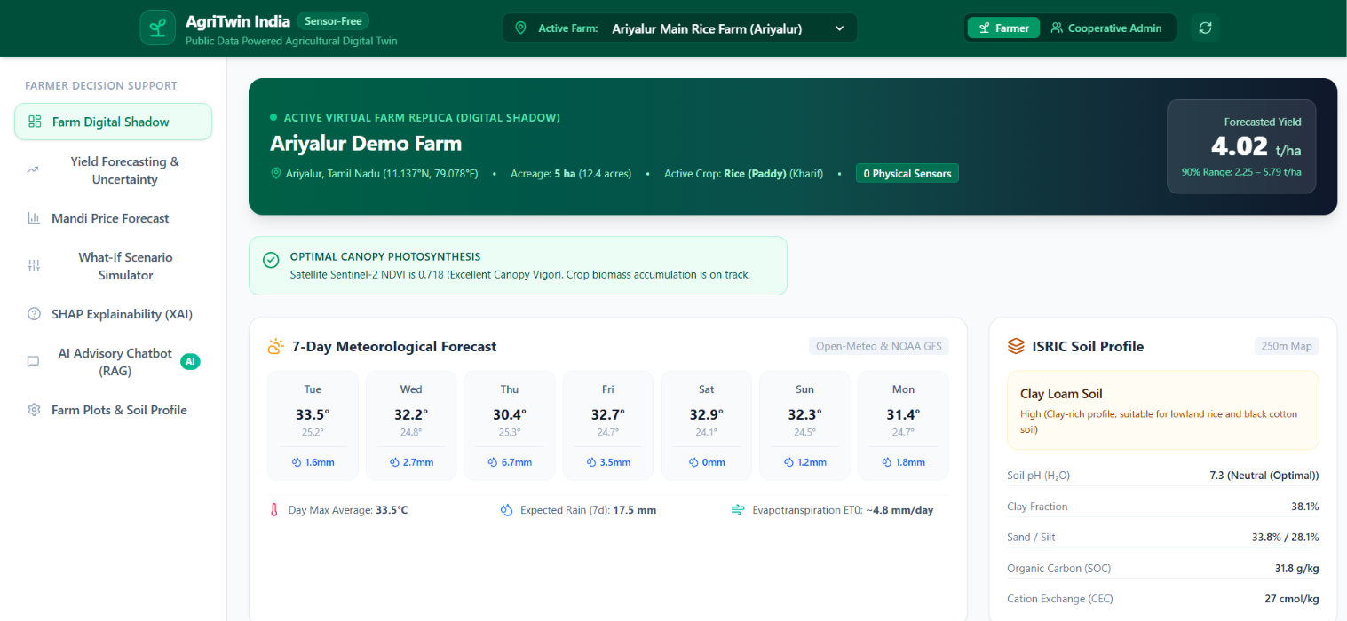

CROP YIELD PREDICTION WITH UNCERTAINTY:
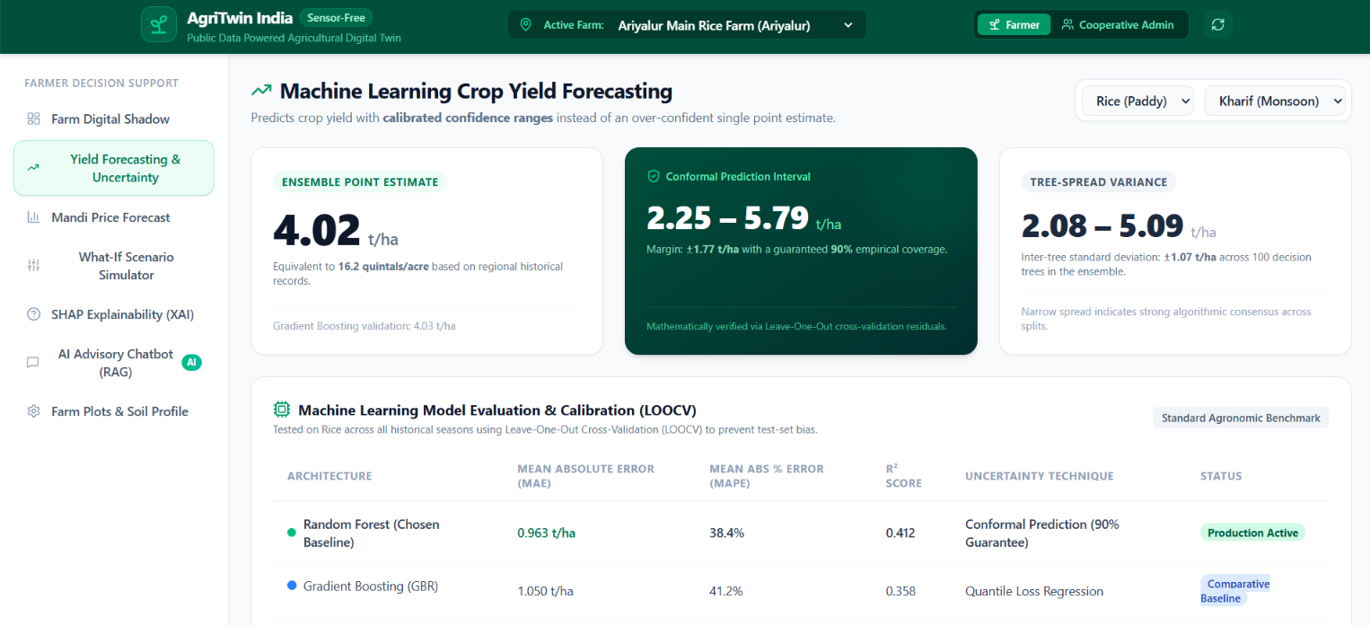

CROP PRICE FORECAST:
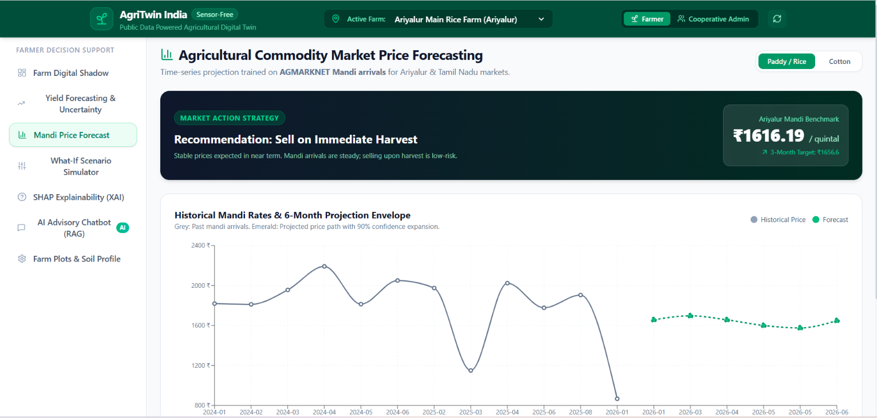

SCENARIO ENGINE:
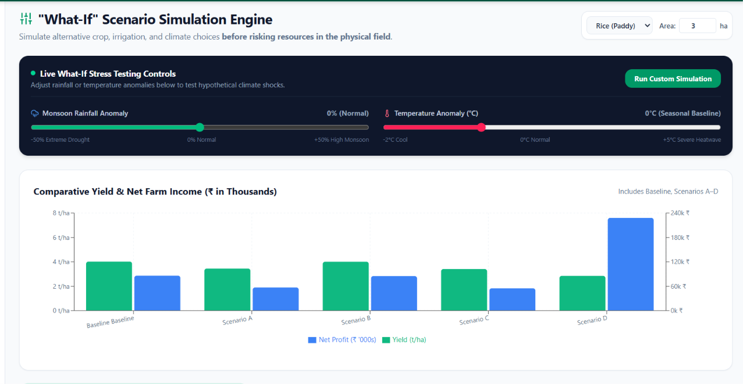

SHAP FEATURE:
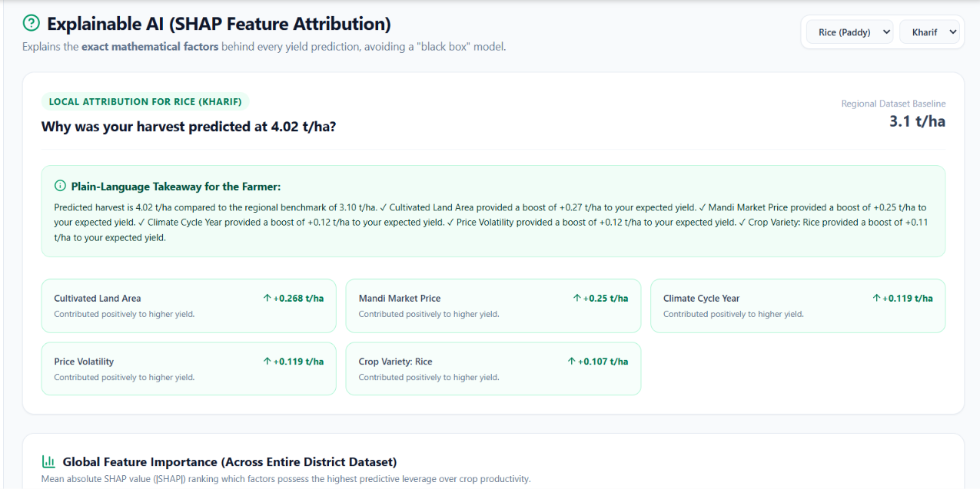

AI CHATBOT:
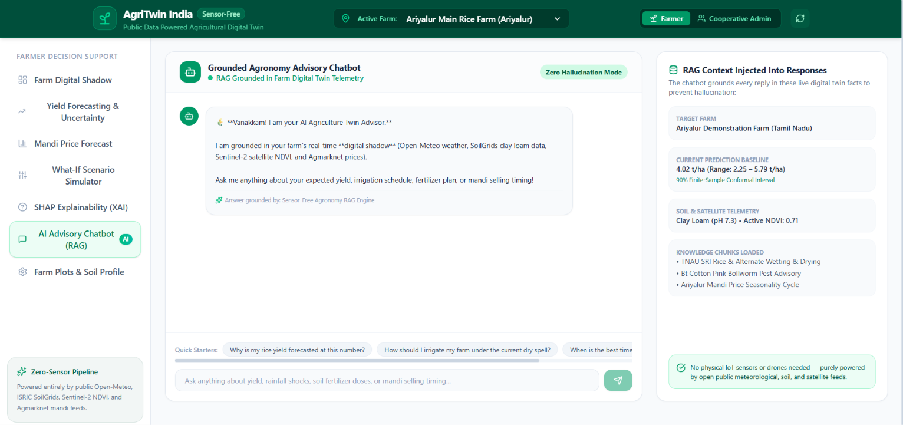

FARM PROFILE MANAGEMENT:
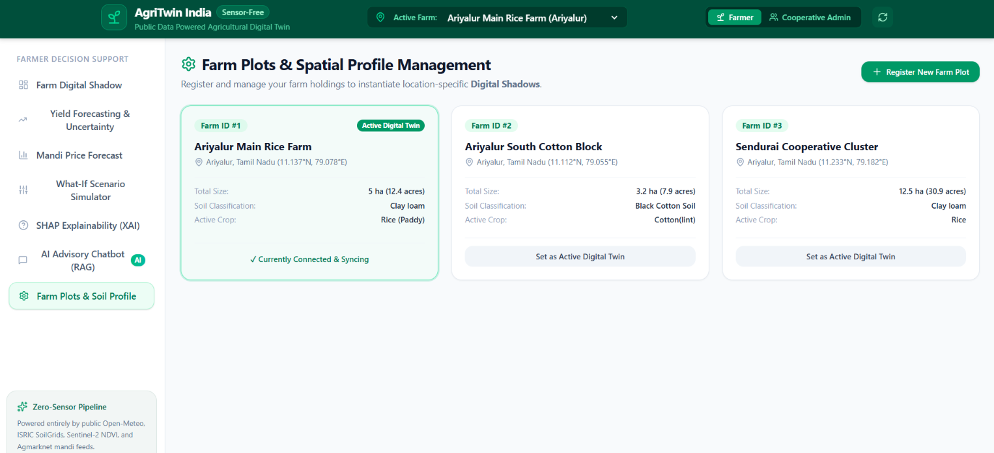

12.SUMMARY:

The project “Agriculture Farm Digital Twin for Scenario Analysis” develops a software-based digital representation of a farm for agricultural decision support without requiring physical IoT sensors. The system uses public weather, soil, historical crop yield, market price, and vegetation information to represent the farm and analyse its conditions. A Random Forest model is used for crop yield prediction, while conformal prediction provides an uncertainty range for the prediction. The system also provides market price projection and what-if scenario analysis by changing rainfall and temperature conditions. The scenario results are further used to estimate production, revenue, input cost, and net profit. SHAP is used to explain the factors influencing the yield prediction, and a RAG-based chatbot provides farm-related recommendations using the digital farm information and TNAU agricultural knowledge. The complete system is implemented using Flask, React/Vite, PostgreSQL/PostGIS with SQLite fallback, and provides an interactive dashboard for viewing predictions, scenarios, explanations, and recommendations

REFERENCES: (minimum 15 papers)

- Haji Seyed Asadollah, S. B., Jodar-Abellan, A., & Pardo, M. Á. (2024). Optimizing machine learning for agricultural productivity: A novel approach with RScv and remote sensing data over Europe. Agricultural Systems, 218, 103955.
- Kamangir, H., Sams, B. S., Dokoozlian, N., Sanchez, L., & Earles, J. M. (2024). Large-scale spatio-temporal yield estimation via deep learning using satellite and management data fusion in vineyards. Computers and Electronics in Agriculture, 216, 108439.
- Mitsanis, C., Hurst, W., & Tekinerdogan, B. (2024). A 3D functional plant modelling framework for agricultural digital twins. Computers and Electronics in Agriculture, 218, 108733.
- Cohen, Y., Malka, A., Goldwasser, Y., Scudiero, E., Goldshtein, E., Keisar, O., Lidor, G., & Ravid, G. (2025). Leveraging satellite imagery and yield records to assess in-season maize field functionality with machine learning classification. Computers and Electronics in Agriculture, 238, 110809.
- Onoufriou, G., Hanheide, M., & Leontidis, G. (2023). Premonition Net, a multi-timeline transformer network architecture towards strawberry tabletop yield forecasting. Computers and Electronics in Agriculture, 208, 107784.
- Cesco, S., Sambo, P., Borin, M., Basso, B., Orzes, G., & Mazzetto, F. (2023). Smart agriculture and digital twins: Applications and challenges in a vision of sustainability. European Journal of Agronomy, 146, 126809.
- Paudel, D., de Wit, A., Boogaard, H., Marcos, D., Osinga, S., & Athanasiadis, I. N. (2023). Interpretability of deep learning models for crop yield forecasting. Computers and Electronics in Agriculture, 206, 107663.
- Leukel, J., Zimpel, T., & Stumpe, C. (2023). Machine learning technology for early prediction of grain yield at the field scale: A systematic review. Computers and Electronics in Agriculture, 207, 107721.
- Tripathi, A., Kaushal, I., Revolti, A., Benedetti, L., & Dallasega, P. (2025). Digital twin driven quality control in smart mobile factories: A framework in precast manufacturing. Procedia CIRP, 134, 801–806.
- Purcell, W., & Neubauer, T. (2023). Digital twins in agriculture: A state-of-the-art review. Smart Agricultural Technology, 3, 100094.
- Singh, N., Wang'ombe, J., Okanga, N., Zelenska, T., Repishti, J., G K, J., Mishra, S., Manokaran, R., Singh, V., Rafiq, M. I., Gandhi, R., & Nambi, A. (2024). Farmer.Chat: Scaling AI-powered agricultural services for smallholder farmers. arXiv preprint.
- Manogna, R. L., Dharmaji, V., & Sarang, S. (2025). Enhancing agricultural commodity price forecasting with deep learning. Scientific Reports, 15(1), 20903.
- Petropoulos, T., Benos, L., Berruto, R., Miserendino, G., Marinoudi, V., Busato, P., Zisis, C., & Bochtis, D. (2025). Interpretable machine learning for legume yield prediction using satellite remote sensing data. Applied Sciences, 15(13), 7074.
- Jácome Galarza, L., Realpe, M., Viñán-Ludeña, M. S., Calderón, M. F., & Jaramillo, S. (2025). AgriTransformer: A transformer-based model with attention mechanisms for enhanced multimodal crop yield prediction. Electronics, 14(12), 2466.
- Lal, B., Shukla, A., Agrawal, A. K., Ramasamy, R. K., & Dubey, P. (2026). Attention-based transformer framework with predictive uncertainty quantification for multi-crop yield forecasting. Computation, 14(4), 93.

